Reduce App Size(IPA)
- Remove Demo mode from Cloud build to reduce size

Reduce App Size (APK)
- APK generated from cloud build is around 250MB size approx.
- It can be reduced to 75 MB approx if we built it only for one architecture.
- In SvcAssetMgr, Go to androidmanifest.xml and set true for “android:extractNativeLibs”
- In app.gradle keep abiFilters for only ‘arm64-v8a’. It will build app only for 64 bit architecture.
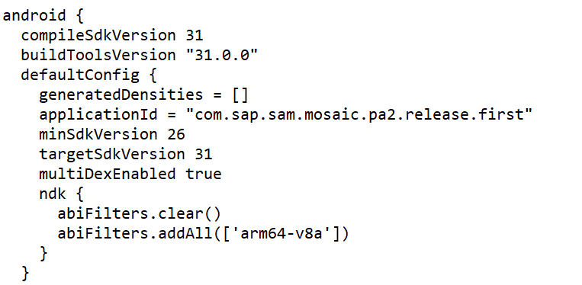

Creating Local Keystore
- Open the MDKClient_SDK folder and run command “keytool -keystore clientkeystore -genkey -alias client “.
- Once prompted, enter the information required to create keystore.

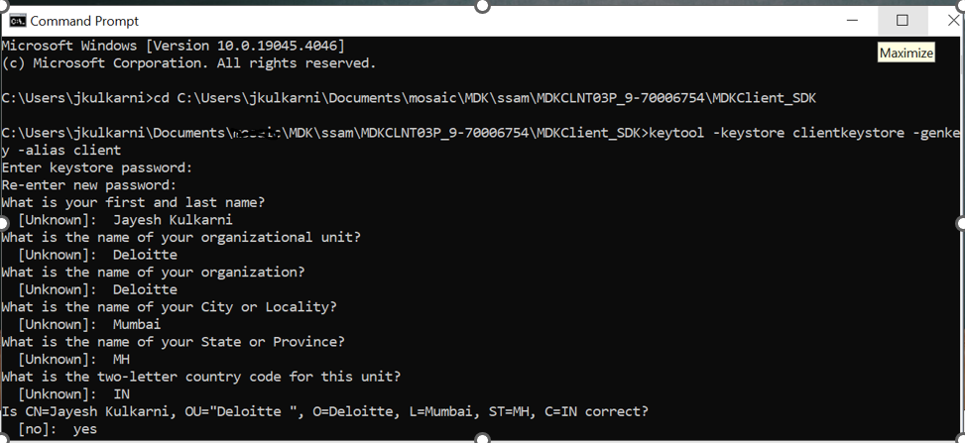

Creating Local Certificate
- In the same terminal use command “keytool.exe -genkey -v -keystore release.keystore -alias client -keyalg RSA -keysize 2048 -validity 1800”.
- It will generate self sign certificate with validity of 1800 days
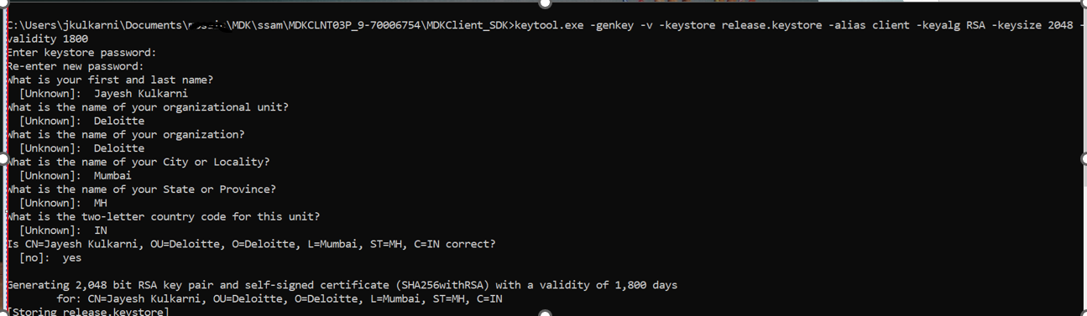

Creating Release Build
- With the self sign certificate and keystore you can create release build which is not debug enabled and can be onboarded to play store.
- Go to SvcAssetMgr in the command prompt and use below command.
- tns build android --release --key-store-path \MDK\ssam\MDKCLNT03P_9-70006754\MDKClient_SDK\release.keystore --key-store-password test@2210 --key-store-alias client --key-store-alias-password test@2210
